AIMS Biophysics, 4(2): 316-336.

DOI: 10.3934/biophy.2017.2.316  
Received: 08 January 2017  
Accepted: 18 April 2017  
Published: 24 April 2017

http://www.aimspress.com/journal/biophysics

***Research article***

**Monte Carlo simulations of the distributions of intra- and extra-vesicular ions and membrane associated charges in hybrid liposomes composed of negatively charged tetraether and zwitterionic diester phospholipids**

**István P. Sugár 1,* and Parkson Lee-Gau Chong 2,\***

**1**Department of Neurology, Icahn School of Medicine at Mount Sinai, New York, New York 10029, USA

**2**Department of Medical Genetics and Molecular Biochemistry, The Lewis Katz School of Medicine at Temple University, Philadelphia, Pennsylvania 19140, USA

**\* Correspondence:** Email: [istvansugar0@gmail.com](mailto:istvansugar0@gmail.com); [pchong02@temple.edu](mailto:pchong02@temple.edu); Tel: +215-707-4182.

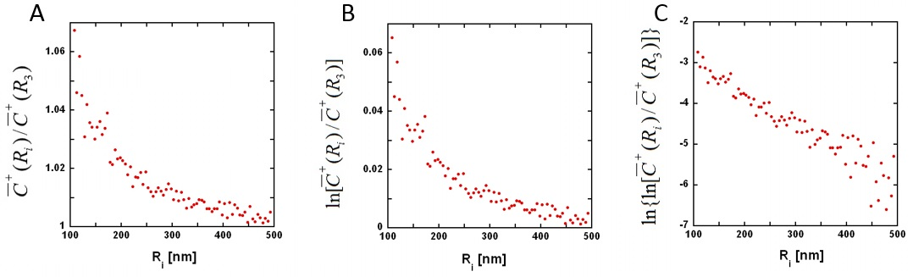

**Figure S1.** Single- and double-logarithm of the average concentration of positive extra-vesicular ions. (A) The average concentration of positive extra-vesicular ions are plotted in Figure 4D. Here the same concentrations are divided by the average concentration at R3, , and plotted against the radial distance Ri.  (B) The logarithm of  is plotted against the radial distance Ri. (C) The logarithm of  is plotted against the radial distance Ri.

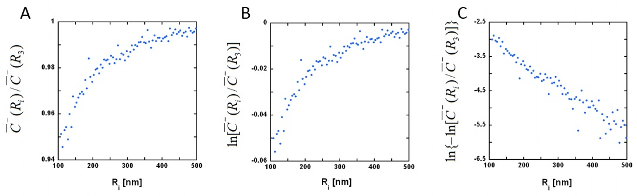

**Figure S2.** Single- and double-logarithm of the average concentration of negative extra-vesicular ions. (A) The average concentration of negative extra-vesicular ions are plotted in Figure 4B. Here the same concentrations are divided by the average concentration at R3, , and plotted against the radial distance Ri.  (B) The logarithm of  is plotted against the radial distance Ri. (C) The logarithm of  is plotted against the radial distance Ri.

By assuming Boltzmann distribution the electric potential of an ion was calculated from the simulated average ion concentration (shown in Figure 2–4) as follows:  By using the same equation the error of the potential was calculated too and plotted in Figure S3.

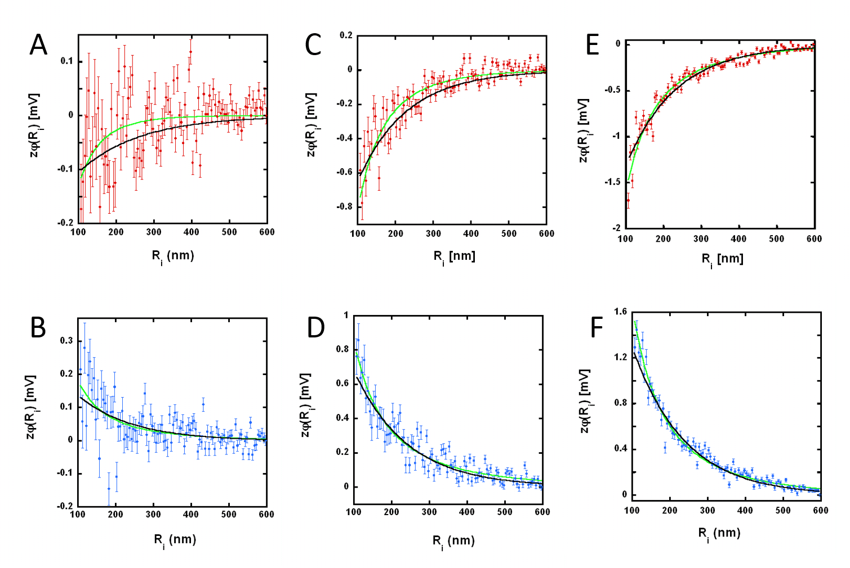

**Figure S3.** Simulated and fitted electric potentials of extra-vesicular ions. The electric potential, , obtained from the simulated ion concentration, is plotted against the shell radius (Ri). Red and blue dots and the error bars refer to positive and negative ion, respectively. Green curve: the approximate solution of the Poisson-Boltzmann equation (given in the Introduction and in Table S1) is fitted to the simulated data. The values of the parameters,  and  obtained from the weighted fit are listed in Table S1. Black curve: shows a simple exponential curve derived from Eq.16 (i.e.). The values of the parameters, *a* and *b*, are listed in Table 1. (A,B) N3 = 1000; (C,D) N3 = 5000; (E,F) N3 = 10000.

**Table S1**. Definition of curves fitted to average extra-vesicular positive and negative ion concentrations in Figure S3.

|  |  |  |  |
| --- | --- | --- | --- |
| Figure | [mV] | [ [nm-1] | Correlation coefficient |
|  | | | |
| Figure S3A, $N_{3}=1000$ | $$0.12099±0.035977$$ | $$0.0088688±0.0037484$$ | $$0.26801$$ |
| Figure S3C, $N_{3}=5000$ | $$0.76901±0.035773$$ | $$0.0056936±0.00039195$$ | $$0.84897$$ |
| Figure S3E, $N_{3}=10000$ | $$1.5198±0.024412$$ | $$0.0035384±0.0000968$$ | $$0.96134$$ |
|  | | | |
| Figure S3B, $N_{3}=1000$ | $$0.17206±0.025316$$ | $$0.003776±0.00091393$$ | $$0.46954$$ |
| Figure S3D, $N_{3}=5000$ | $$0.80761±0.028135$$ | $$0.0026494±0.00017948$$ | $$0.88662$$ |
| Figure S3F, $N_{3}=10000$ | $$1.5661±0.02443$$ | $$0.0032116±0.00008817$$ | $$0.97207$$ |

© 2017 Parkson Lee-Gau Chong, et al., licensee AIMS Press. This is an open access article distributed under the terms of the Creative Commons Attribution License (http://creativecommons.org/licenses/by/4.0)