  https://www.aimspress.com/journal/aci | Applied Computing and Intelligence  4 (1): x–xx  Here is just some place-holder data. The press will make this part after the paper is accepted.

Article type: Research article | Case study | Review | Survey | Opinion | Tutorial | Editorial

Author instructions
A good title is brief but informative: One-line is best
John Do¹, Author B² and Author C^{2,}*
¹ College of Computing and Software Engineering, Kennesaw State University, GA, USA
² Remove these numbers in case all authors have the same affiliation.
* Correspondence: Email and telephone of the corresponding author here.
Academic Editor: Leave it blank. The journal will take care of it.
Abstract: Give a brief summary of the work including the research goal, key contribution, and its main achievement. Abstract should answer the questions: what, why, and how. What is the research topic? Why was it studied? Give one or two key points of the new contribution. The most important result should be given. Try to summarize the main contribution or result as one clear (citable) take-away message. Abstract is an independent component apart from the main paper.
Keywords: keyword; another keyword; maximum eight

- Introduction
Define the research problem. Explain why it is important to study. Explain the current state-of-the-art to address this problem. Why it is not sufficient; what is missing? Give a key idea for the new contribution. What methodology you have chosen to address the problem?
All concepts included in the title of the paper should be defined in the paper. The terms used in the title are expected to guide the structure of the rest of the paper. Whatever terms you choose, use them consistently throughout the paper. Avoid using acronyms and computer jargon.
Make it clear whether the paper proposes a new computer algorithm or provides new insight into the problem. Are you comparing it against existing algorithms using some evaluation measures? If yes, provide some overall evaluation value (or %-improvement) already in the introduction. In the experiments, try to provide insight into why the new algorithm works better and when it works better. A good paper tries to answer what made the difference, and what are the effecting factors. Doing an ablation study is always better than measuring just overall performance.
All methods and results should be reproducible. Is the code used publicly available? How about data? If presenting new data, it is strongly recommended to publish the data to have more impact (and more citations) on the work.
- Content
Content consists of text, figures, and tables. Algorithms or pseudo codes can also be included.
2.1. Text content
Most important is that the reader understands what has been done in the paper. The main criteria for a scientific paper are that (1) the methodology and results are valid, (2) they can be reproduced by others. Sharing code will help in this.
Focus on explaining the overall process but also give enough details. You can use Tables to summarize the key design choices and their parameters. No need to explain standard tools to process the data. If external software libraries were used, then give pointers to them. Give pointers to the data used, and citations to scientific papers where they are described.
Text content should be edited carefully. Use grammar-checking tools routinely, and professional proofreading services if needed for language editing. The submitted paper should not contain typos. Line spacing, spacing, and punctuation between the words and sentences should also be set properly. Too careless editing in this regard may cause rejection without further review of the content.
Papers with multiple authors are expected to be read (and improved) by all the authors. If you have many co-authors, make sure they all have agreed and contributed to the paper. In the case of student-authored papers, make sure the supervisors also contribute. Otherwise, consider asking your friends and colleagues to give feedback before submitting. The journal cannot provide excessive technical feedback for papers.
2.2. Visuals
Visual examples and graphical plots can be very helpful, but they require good design. The font sizes of all text components should be large enough to be easily read without zooming. This applies to all details including axis legends and their values. The font sizes should be roughly the same as in the main text (12 pt). Sub-titles and key components may be bigger and some other text slightly smaller (10 pt).
For figures consisting of multiple sub-components, do not use unnecessary labels (a) and (b) below the images as in Figure 1. Instead, add a sub-title above to each component with a suitable size font as shown in Figure 2. If you copy-paste material from elsewhere, make sure you are authorized for it, and always cite the source.
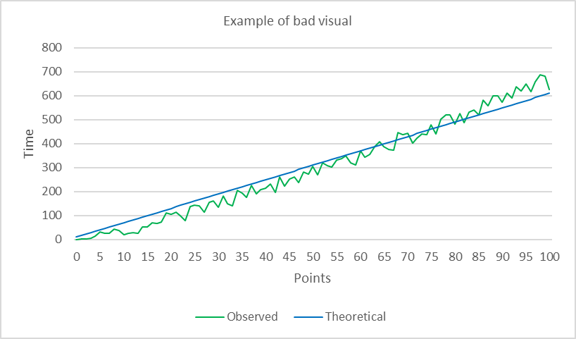 | 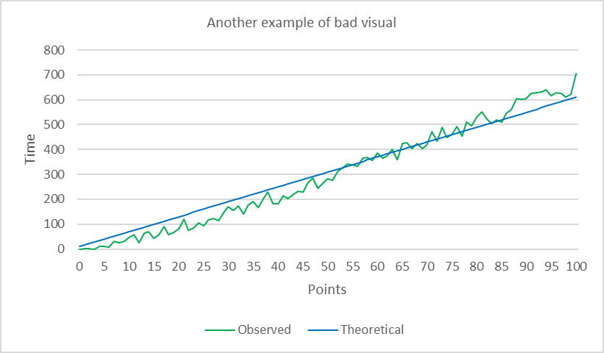  (b)
Figure 1. Two examples of bad visuals. This figure has two bad examples: (a) an example of bad visual, and (b) another example of bad visual. Other problems here are small font sizes, lines that are hard to differentiate from each other, and useless titles inside the graphics, and borders.

Good example | Another good example
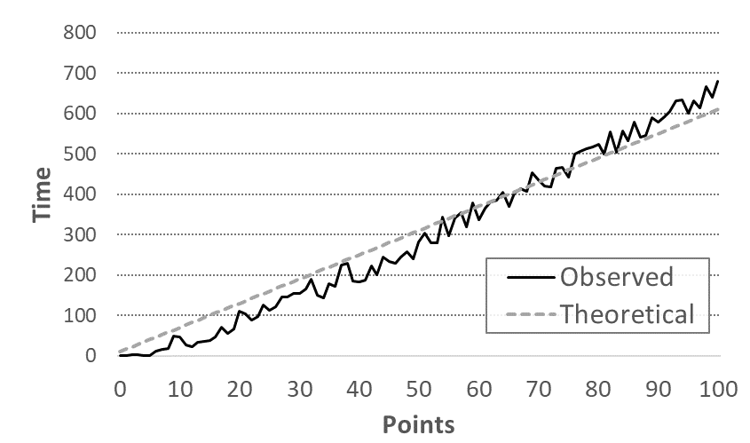 | 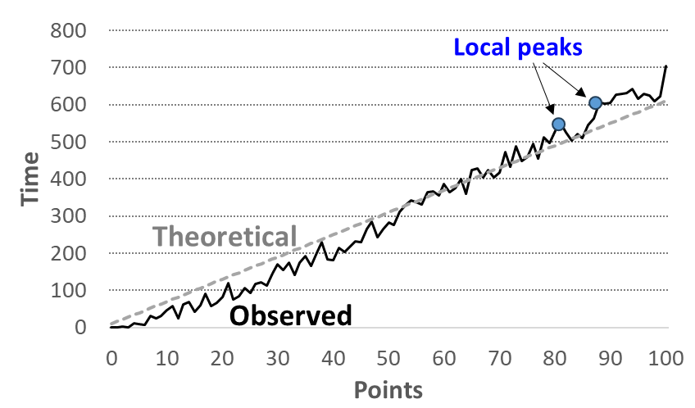
Figure 2. Two visual examples. Use style and width to differentiate the lines. Embed the legend box inside the graph (left). You can also manually edit the legends next to the lines. Colors can be saved for demonstrating some important detail (right).
- Structure and layout
Have a clear structure. If the paper has an experimental section, consider having the experimental setup into its own section describing the data, comparative methods, and evaluation measures. The results can then have their own section. Balance the sizes of all sections.
The first-level headline is numbered and bold. The second-level headlines are in italics. Both have font sizes of 12 pt. There is a space of 12 pt before and after the headline. Each paragraph begins with an indentation of 0.63 cm (the same by using the Tab key once).
3.1. Sub-sections
The second-level headline is also numbered and has a default space of 6 pt before and after it. If the paper has sub-section 3.1, sub-section 3.2 is also expected to appear.
3.1.1. The third-level headline (if necessary)
Avoid using third level sub-sections. If really necessary, the third-level headline should be numbered and italicized with a font size of 12 pt, indented by 0.63 cm (the same by using the Tab key once). The third-level headline has a default space of 6 pt before and after it. Any lower headline should be avoided.
3.1.2. Layout and paper size
Use the layout and A4 page size (8.5 × 11.0 in, or 21.59 × 27.94 cm) and margins as set in this document. All font sizes are Times New Roman, and the default size is 12 pt. All paragraphs are aligned both left and right.
For figures and tables, use the styles as shown in Figures 1 and 2, and Table 1. All text in figures should be big enough to be visible without zooming (10 pt or higher). Recommended font size for tables is 10 pt but you can vary between 8 to 12 pt depending on the best fit. Footnotes style is here.
Table 1. Summary of the style settings.
Issue | Font size | Spacing (before/after)
Title | 16 pt bold | just copy it as it is
Section titles | 12 pt bold | 12 pt / 12 pt
Sub-section titles | 12 pt italic | 6 pt / 6 pt
Main text | 12 pt | 0 pt / 0 pt
Figures | 12 pt | 0 pt / 0 pt
Tables | 10 pt | 3 pt / 3 pt

3.2. Mathematical formulae
Mathematical formulae should be typed using MS Word Equation or MathType with a font size of 10-12 pt, and 6-8 pt for subscripts and superscripts. Every equation should appear in a separate line with 6 pt between two formulae in separate lines. Use numbering and tabulations as shown below:
$\lim_{x→a^{+}}{f\left(x\right)}=±∞$ or $\lim_{x→a^{-}}{f\left(x\right)}=±∞$ (1)
$\lim_{x→∞}{f\left(x\right)}=a$ or $\lim_{x→-∞}{f\left(x\right)}=b$ (2)
To cite a formula in the text, use a number like Equation (1), Eq. (2), or (1).
4. Reference style and citation
The journal uses a numbered style for referencing. Cite references in the text by placing number(s) in square brackets by the end of a sentence [1,2], or immediately after the Author’s name, for example, Jackson [3] outlined that …. If an article has two authors, list both surnames, e.g., Wang and Guo [4] reported …. If an article has more than six authors, use the first author’s surname and et al., e.g., Chen et al. [9] studied ….
Three or more consecutive references can be placed in the same brackets separated by a hyphen [5–8]. References with separate numbers can be placed in the same square brackets separated by commas [2,6,9]. Follow the examples shown in the list of references below for different types of publications [10–14]. We recommend using software such as EndNote, RefWorks or Mendeley to manage the references.
We recommend all references are cross-referenced between their appearances in the text and in the Reference list. AIMS production will require DOI (if there is one).
5. Review process
Applied Computing and Intelligence is an open access journal published by AIMS Press. There are no publication charges, so the papers are free both for authors and readers via the journal website. Authors retain copyright and legal responsibilities of the content.
Manuscripts are submitted to the journal via the journal website. The journal holds a high standard in peer review. All submissions are reviewed by at least three independent reviewers. A manuscript to be accepted must have a new contribution with scientific relevance to the reader. All methods and experiments must be valid and flawless, well documented, repeatable, and the manuscript easy to read in all parts.
6. Conclusions
You can briefly repeat the main contribution, but the focus should be on summarizing the main results. Did the paper solve some open problems? How (or how much) did it improve the best existing solution? Who can benefit from this result? What else can we learn from this? What worked and did not work, and why? If there was only one thing the reader could remember from the paper, what would it be? Give a clear take-away message in a manner that is citable by others.
Good luck with your research. And oh, do not write one-sentence paragraphs. 😊
Use of AI tools declaration
The authors declare they have not used Artificial Intelligence (AI) tools in the creation of this article.
Acknowledgments
Acknowledgments can be added here if needed.
Conflict of interest

References
- N. A. Albelbisi, A. S. Al-Adwan, A. Habibi, Self-regulated learning and satisfaction: A key determinants of MOOC success, Educ. Inf. Technol., 26 (2021), 3459–3481. doi: 10.1007/s10639-020-10404-z.
- P. Fränti, S. Sieranoja, How much k-means can be improved by using better initialization and repeats? Pattern Recogn., 93 (2019), 95−112. doi:10.1016/j.patcog.2019.04.014 [open access journal/magazine]
- P. A. Archila, J. Molina, A. M. T. de Mejia, Fostering bilingual written scientific argumentation (BWSA) through collaborative learning (CL): evidence from a university bilingual science course, Int. J. Sci. Educ., 43 (2020), 1–29. doi: 10.1080/09500693.2020. 1844922. [open access journal]
- Y. Wang, W. W. Guo, Reproducing the realistic compressive-tensile strength ratio of rocks using discrete element model, in Rock Anisotropy, Fracture and Earthquake Assessment, Y.G. Li, Ed. 2016, De Gruyter. 142−174. doi: 10.1515/9783110432510-003. [book chapter]
- S. L. Jackson, Research Methods and Statistics: A Critical Thinking Approach, 3rd ed. 2009, Belmont, CA, USA: Wadsworth, Cengage Learning. [book]
- R. Bolton, Second wave of university job cuts coming next year, in Financial Review, 2020, The Australian Financial Review: Sydney, Australia. [newspaper]
- A. Chiappe, H. C. Ibarra, L. Lizasoain, Learning in the openness: the lost way of the MOOC, Digit. Educ. Rev., 38 (2020), 42−60. doi: 10.1344/der.2020.38.42-60. [digital journal]
- P. Fränti, Dynamic map handling, GIM International, 17 (2003), 28−31. [magazine]
- H. Chen, F. Li, L. Wang, Y. C. Jin, C. H. Chi, L. Kurgan, et al., Systematic evaluation of machine learning methods for identifying human-pathogen protein-protein interactions, Brief. Bioinform., 22 (2021), bbaa068. doi: 10.1093/bib/bbaa068. [journal with more than 6 authors]
- W. Guo, Magnetic petrophysics and density investigations of the Hamersley Province, Western Australia: implications for magnetic and gravity interpretation, PhD thesis, 1999, The University of Western Australia: Perth, Australia. p. 121. [thesis]
- Z. Li, W. Guo, C. M. Powell, Timing and genesis of Hamersley BIF-hosted iron deposits: a new palaeomagnetic interpretation, 2000. Minerals & Energy Research Institute of Western Australia: Perth, Australia.
- H. Chen, Y. Jin, L. Wang, C. H. Chi, J. Shen, HIME: Mining and Ensembling Heterogeneous Information for Protein Interaction Predictions, Faculty of Engineering and Information Sciences - Papers: Part B. 4201. [research report]
- B. C. Kuo, H. H. Ho, C. H. Li, C. C. Hung, J. S. Taur, A kernel-based feature selection method for SVM with RBF kernel for hyperspectral image classification, in IEEE Journal of Selected Topics in Applied Earth Observations and Remote Sensing, 7 (2014), 317−326. doi: 10.1109/JSTARS.2013.2262926. [traditional journal]
- B. Hegerty, C. C. Hung, K. Kasprak, A comparative study on differential evolution and genetic algorithms for some combinatorial problems, 8th Mexican Int. Conference on Artificial Intelligence, (2009), 9−13. [conference paper]
- Department of Education and Training, National Strategy for International Education 2025, The Australian Government: Canberra, Australia, 1−32. [government report/policy paper]
- R. Weinstein, Writing scientific case reports for top-line journals, J. Clin. Apheresis, (2020). doi: 10.1002/jca.21869. [online journal]

©2024 the Author(s), licensee AIMS Press. This is an open access article distributed under the terms of the Creative Commons Attribution License (http://creativecommons.org/licenses/by/4.0)

This is a footnote. It has a font size of 10 pt.

